Ninjakita server setting up S.O.P

# System environment checking:

1. Check system time、time zone、NTP server time synchronous
2. Check virtual memory amount ,can’t less than physical memory.
3. Set the space of Disk C as 70-80 G(Depend on the amount of virtual memory)
4. Install the package of chinese
5. Auto-reboot coursed by shutting down system error, allocate as below:

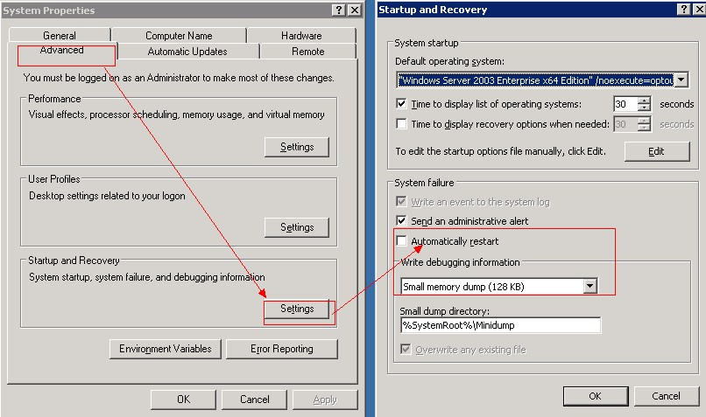

# Game environment installing:

1. Extract system environment package under d:\tools
2. Run D:\tools\gamesvr-install.bat
3. Finish running “logoff”
4. Install rsyncserver

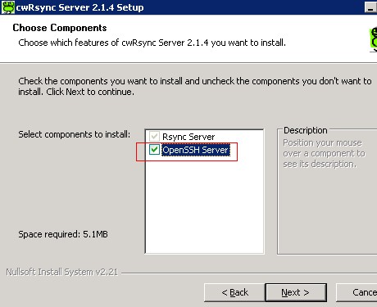

1. Bulid ssh trust relationship between servers
2. Input IP = Local IP (Internal IP = 192.168.xx.xx)
3. Open cmd , input below order



1. Enter “bash” environment, run script as below



1. As below, choose l, than it will show all system account of windows, input your system account, create ssh account.

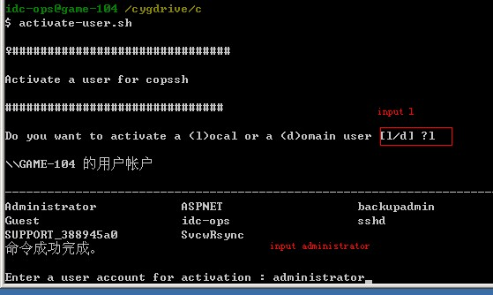

1. Quit when account created.

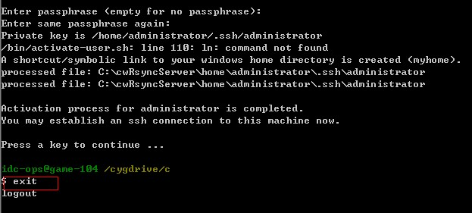

1. Run below order ,create ssh public key id_dsa.pub and private id_dsa

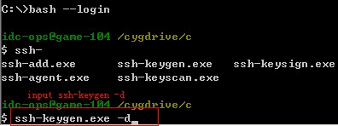

1. As below, copy content of id_dsa.pub to locality or authorized_keys files of remote machine.

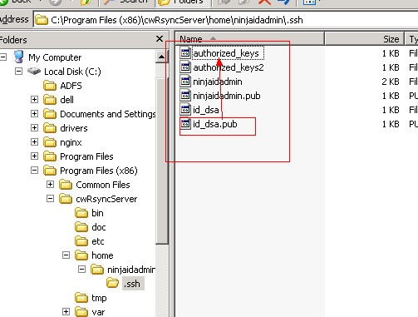

# Game installing

1. Place the complete package of the client file apache and server file app under d:\op\update
2. Change game configuration

Client：

Client configuration file route: d:\op\update\apache\sever, as the following shows:：

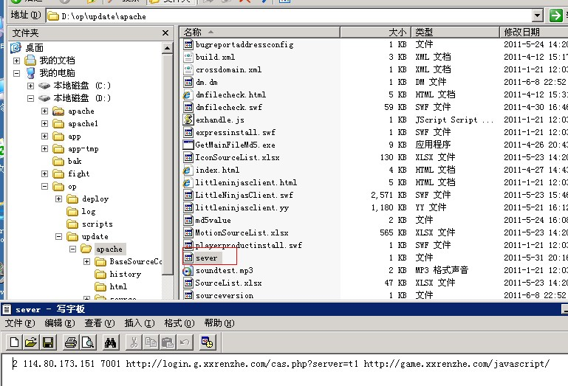

the file format of server is as follows:

Choose the login mode, the entrance port ip http:// platform loadingurl <http://acquire> login loading page url

Annotations as follows:

1. the first parameter chooses login mode: 1. Local login, 2 platform login
2. the second parameter ip: entrance ip.
3. The third parameter entrance port: (if no special change is made, it should be 7001)
4. The fourth parameter platform login url: the site of platform cas login
5. The fifth parameter acquires login loading page url: acquire login loading page url.

Server:

File catalogue of server configuration: d:\op\update \app\bin\config

It is fine to keep most of the configuration files default. There are several configuration to change:

* + - * 1. to change all the ip in game01.properties\ game02.properties\ game03.properties\ gamedb.properties\ pubdata01.properties\ pubdata02.properties\ pubdata03.properties\interior.properties configuration file.
        2. To verify ame01.properties\game02.properties\game03.properties\interior.propertiesplatformlogin = 1 from platform, to verify platformlogin = 0 in local. The value of serviceid can be self-defined and it differs in every region.
        3. The configuration of gamedb.properties shows as follows, connect the port,DB name, account of the DB, connect the password of DB (attention, the value of gameDb.DBPASSWORD and logDb.DBPASSWORD needs to make the password generate encrypted string); the value of gamedb.properties configuration servergroup (attention: Make sure every region differs from each other)

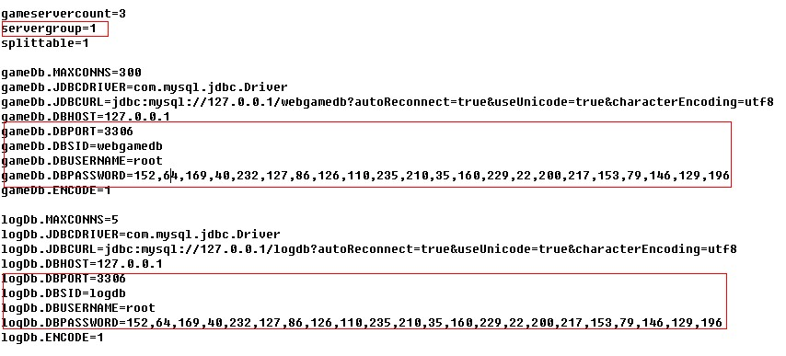

1. the configuration of pubdata01.properties\ pubdata02.properties\ pubdata03.properties shows as follows, connect ip,port, DB name, the account of DB, connect the password of DB (the value of gameDb.DBPASSWORD and logDb.DBPASSWORD needs to make the password generate the encrypted string)

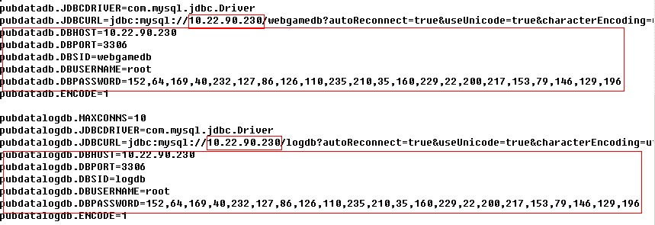

1. app\bin\config\props\serv\game\Resource\FightServer.ini

[fightserver]

fightserver= ip :port in the server where fighting file locates

1. the configuration of interior.properties shows as follows:

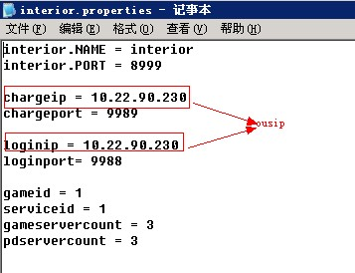

After changing the game configuration, execute Rsync-client.bat and Rsync-game.bat to publish in every server.